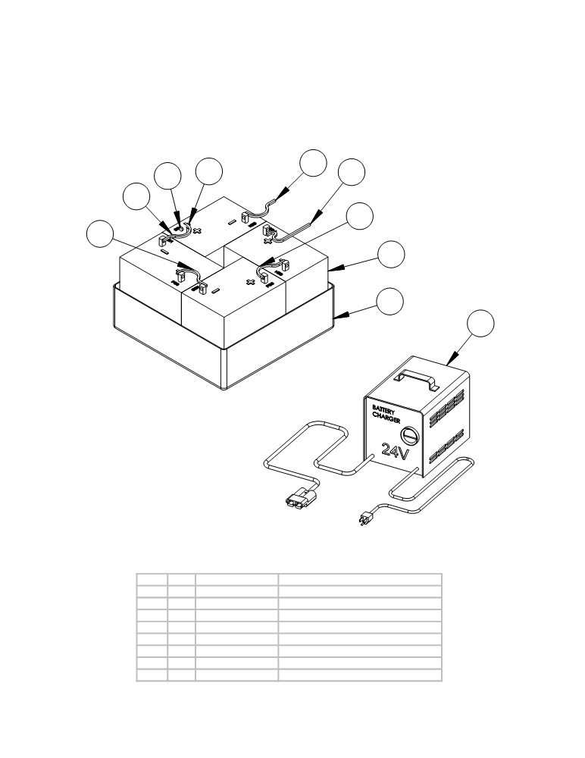

BATTERIES AND CHARGER

6
7 8 5
4
4
4
3

2
1

 | ITEM | SKU | Description | QTY
 | 1 | E88039 | Battery Charger - 36 volt | 1
 | 2 | AS32002 | Battery tray - for 6 batteries | 1
 | 3 | E86277 | Battery 6V 235AH Wet | 4
 | 4 | E11837 | Cable, 6 AWG, Red, 6.00" | 3
 | 5 | E11644 | Terminal Wire - Red, 6GA x 48" | 1
 | 6 | E11823 | Terminal Wire - Black, 6GA x 48" | 1
 | 7 | AS26/32209 | Bolt | 8
 | 8 | E11085 | 1/4-20 FLANGED NUT | 8

ITEM QTY. PART NO. DESCRIPTION
1 1 AS26930 Battery Charger - 24 volt
2 1 AS26002 Battery tray - for 4 batteries
3 4 AS26/32710 Battery - 6 volt
4 3 AS26/32351 Battery connectors
5 1 AS26/32342 Battery to positive terminal
6 1 AS26/32343 Battery to negative terminal
7 8 AS26/32209 Bolt
8 8 AS26/32232 Nut

- 46 -

